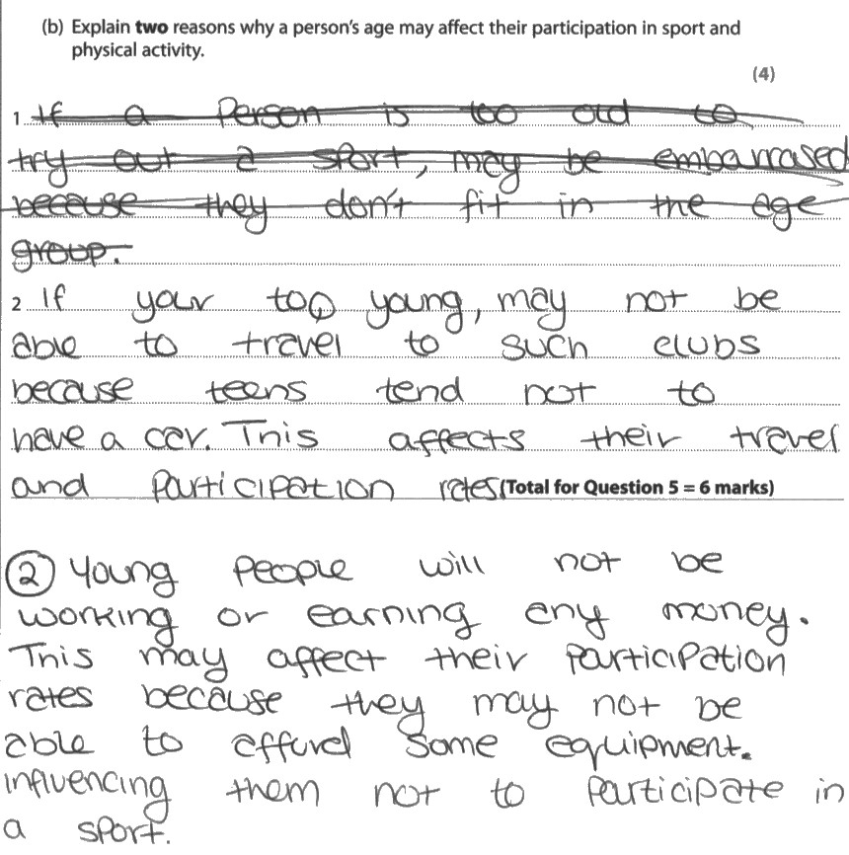
The candidate makes reference to two valid reasons why age can affect participation in sport and physical activity.
Credit is given for identification of access as a potential difficulty:
a young person may have difficulty travelling to a club
money: young people will not be working and earning money and so may not be able to afford equipment
Neither reason then makes a link to an applied sporting example.
This candidate would have gained a third mark if in relation to money a reference had been made to specific sporting equipment eg 'so they may not be able to afford equipment such as golf clubs'. So only 2 marks are given.

