Dear Parents/Carers & Students,

Individual Music Lessons at OBHS

The school operates a system of individual tuition in Guitar, Drums, Piano, Singing, Woodwind,
Strings and Brass, delivered by our expert team of visiting tutors.

Students receive a weekly lesson of 20 or 30 minutes duration, depending on the instrument and teacher. These take place during the school day, on a rotating timetable, to avoid students missing the same curriculum classes every week, when possible. The cost to parents will be £11 per 20 minute lesson, or £16 per 30 minute lesson, payable in half termly instalments in advance. There is some funding available for lessons in certain circumstances, please contact Mr Jay for more details.

Students will need their own instrument. The school holds a small stock of some instruments which may be available to borrow in the short term before committing to the purchase of a new instrument. Contact Mr Jay for details in the first instance. If you intend to purchase a new instrument, please contact Miss Smith (Finance Officer – obhs-pl@setrust.co.uk) for details of the Assisted Purchase Scheme which allows students to buy instruments without paying VAT.

All students are encouraged to consider taking up lessons on an instrument or vocal. If you would like to book a place, please return the application form on the reverse of this letter to either Mr Jay or the instrumental teacher who will get in touch regarding payment.

Yours sincerely,
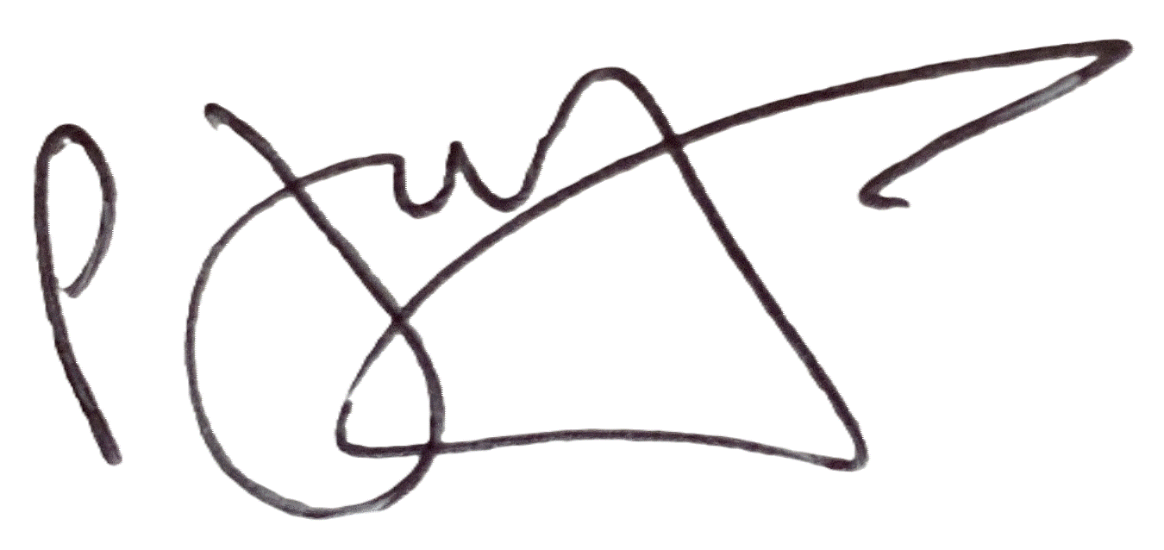

Peter Jay
Curriculum Leader Expressive Arts
p.jay@obhs.org.uk

APPLICATION FORM FOR INDIVIDUAL MUSIC TUITION
Please return to Mr Jay.
Student’s name _______________________________________________________
Instrument/voice: _____________________________________________________
Current standard (e.g. beginner, or grade achieved): __________________________
Address: _____________________________________________________________
Postcode: ________________________________
Telephone: _______________________________
Email: ___________________________________
I would like to book a course of six music lessons during the next half term.
I accept that if my child is absent from lessons due to illness, doctor’s appointment etc. or forgets
to attend the lesson, that there will not be a refund for the missed lesson. If, however, the school has to cancel a lesson a credit will be given during the next half term.

Signed ________________________________ (Parent/Carer) Date ___________

The current instrumental tutors are:
Guitar - WILLIAM HILTON
Drums – TOBY MILLS
Piano – KEITH O’GORMAN
Woodwind - LYDIA O’GORMAN
Singing- LYDIA O’GORMAN

